|  |  |  |
| --- | --- | --- |
|  | **Rochester Institute of Technology**  **Golisano College of Computing and Information Sciences**  **School of Interactive Games and Media**  **2145 Golisano Hall – (585) 475-7680** |  |

**Data Structures & Algorithms for Games & Simulation II**

**IGME 309**

**View Matrix**

This exercise follows lecture D7

1. Under _Binary look for the example solution. It will look like this:

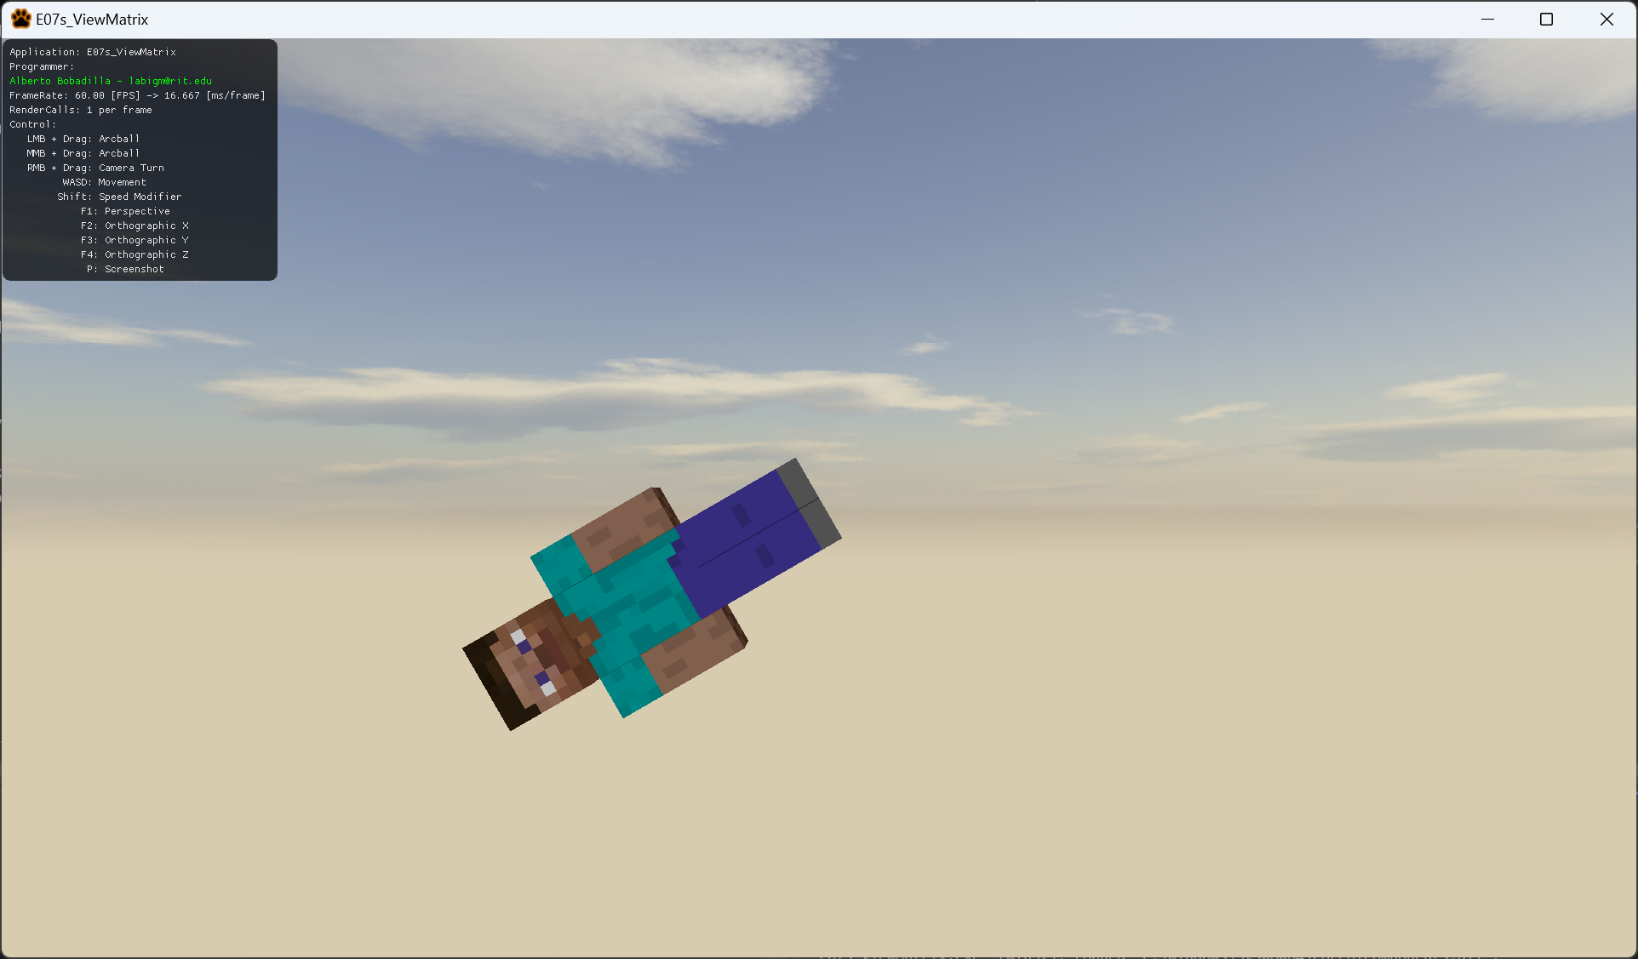

1. For this exercise you will recreate what happened on the example project. This means a couple of things:
   1. When the camera gets closer to Steve he will look larger.
   2. Once the camera gets past Steve it will not look at him anymore.
   3. Steve will not rotate but the camera will.
2. You are not allowed to modify the Model matrix or the Projection Matrix, only the View Matrix.
   1. The skybox is not using the same matrix, if it was connected the sky would rotate with Steve, but a couple of people could get dizzy, so the functionality is disconnected.
3. All your code will be coded in the AppClass.cpp file in said function so this is the only file you need to submit to the dropbox in MyCourses, please do not zip this file.

